Easter, a time for renewal
The signs of Spring bring to mind Joshua 24: 1-28 when God's people renewed their devotion to God. As we renew our covenant with God, we pray for renewal for all believers and revival of the world for Christ. May this Easter bring many new memories of God's faithfulness in your lives. We see it daily in our lives and the lives of others. God is miraculous in who He surrounds each of us with and how he involves us in His plans.
Again this summer, we will be in Czech Republic to help with camp and be a witness to old friends and new alike. Camp is a great place to meet new people in a low stress environment. This year, since camp leaders have and will be blessed with babies, we will do our best to run the daily maintenance of camp. We are fortunate to have Czech and U.S. volunteers or camp would not be possible. This all works in God's timing. Pastor Ed, Ben, Miguel and Mom, a.k.a. Katherine, will come this summer. We are praying for another couple to come along, God willing. We are glad to be present in Czechs' lives, especially since all the missionaries we were connected with in that area are elsewhere serving God.
"No! We will serve the Lord."
(Joshua 24:21b)
Petra has already sent out the invite to camp and we have been planning with Petra, Vojta, Filip, Lucie and Pavel. Our wait is almost up to spend 6 weeks living with friends and sharing their worries, concerns and blessings. We can't wait!
Other ways we will meet new people is through group activities Rick organizes before and after camp. Short hikes, Prague tours, bowling, game night, or taco night are ways we can get friends and new people together in a fun setting. Our CZ hosts keep trying to make us tourists and we just want to stay home.
If God tugs at your heart to support our continued devotion to His work in Czech Republic, please send the amount He determines to our address written out to Kingsburg Community Church with Czech on the memo line. Please pray that Czech believers will not feel isolated since there are few in number. Also, pray for hearts and ears to be open to hear just what God is trying to say through our love of these people and the words He gives us. Please pray for English Camp; July 12-19th, for receptive hearts, utilization of our time there, health and a sense of community. We are so thankful, beyond what that word can describe, for support in our small part of God's work in CZ. We know only God can reach them and feel privileged to be given a part to play. Below are some pictures from our Internet chats with friends who are too far away! There are more, but many of you know Petra (Kubaskova, now Rosicka), Filip and Lucie Hrkal, and the Rehor family; Ivan, Hanka, Filip and Karolina.

Many blessings and Happy Easter,

Rick and Carol Anne Mendenall

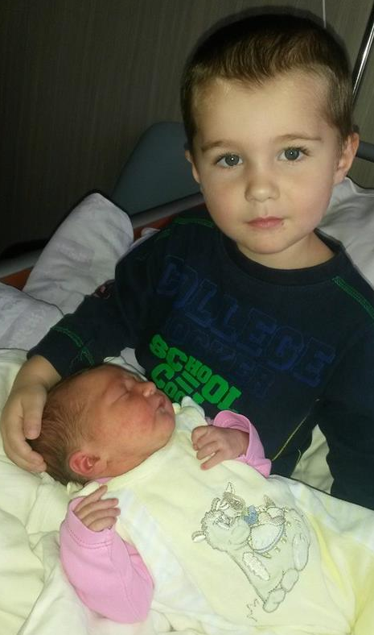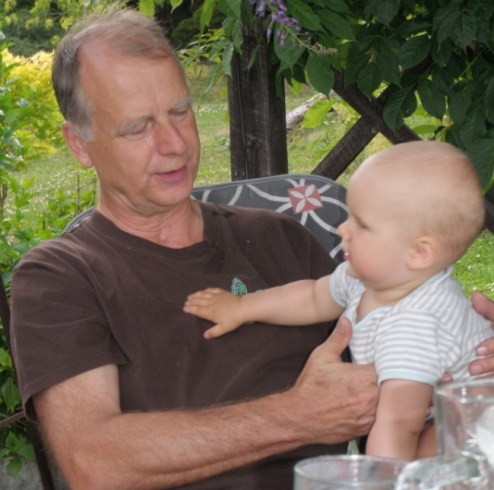
Jasmine Hrkal (Filip & Lucie) Mateos with Jasmine Stepan Rehor & Grandpa Ivan

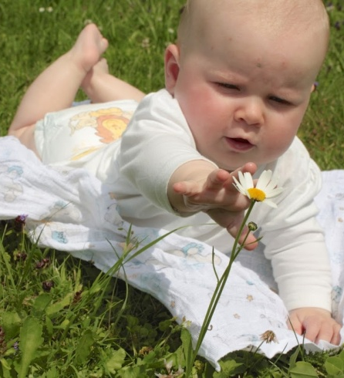
Anika Rosicka (Petra & Vojta) and ?Due July! Martina & Mom-Veronika

