Czech Republic Team Update May 2016
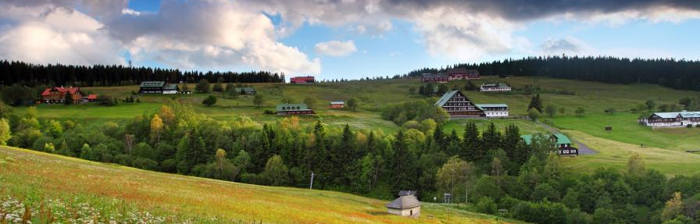

Hello to you all,  Well, the bags are not packed yet, but the lessons and logistics of camp are done! Our VBS bible lessons, music, games and crafts, and adult English lessons for English Camp are ready to go! Now for shopping since we can’t get everything we need in Czech Republic. We have had fun getting to know each other better as we get ready. Customs, language basics, camp activities and schedules are just part of what we have worked on.  Scripture is explicit on the need to share the gospel. We have watched great videos on how to build relationships with people, then listen to their stories, before sharing faith. Whether you subscribe to Greg Mortenson’s Three Cups of Tea to promote peace and build infrastructure, or Gary Poole’s Living in 3D, the way into people’s hearts is through relationships and listening.  Our team recently watched Here Am I, Send Me found below from Bent Tree, a church in Texas. We have talked on how we all have what it takes to share Christ; Willingness. Check this video out! https://vimeo.com/channels/465130.  We wanted to take a moment to thank you for your support of this missions  Information:  http://czechhimout.weebly.com/cz-blog  The above site and live link will take you to our blog. Information on travel, where we are and what we are doing will be posted most days. Pictures from English Camp will be updated daily and can be viewed under CZ English Camp. An occasional post will also be on Facebook, KCC Page. | project in Czech Republic. We cannot wait to go with God's direction and be his ambassadors. The Czech people are so heart-warming and inspirational and we get to be a part of their lives due to you! Thank you so much!  Please be in prayer for…  * Energy-the end of the school year and our work in CZ! We will be 9 hours different in CZ.  * Change- As Pastor Ed said, sometimes we are resistant to change. Czech Republic is different in many ways.  * Communication- We have a great team and want to make sure our encouragement and love are obvious to each other and definitely to the Czechs despite language and cultural barriers.  * Fine Tuned- We pray we are tuned in to Christ and the words the Holy Spirit will give us to convey His message.  Important Dates:  June 26th Commissions of Team 8:30  June 29th Rick&Carol Anne leave for CZ  July 7th KCC Team leave for CZ  July 10th-17th English Camp  July 18th-20th Meetings after camp  July 21st KCC Team flies to USA  Aug. 2nd Rick and Carol Anne fly to USA  Thanks for all your help,  KCC Mission to Czech Republic  Ed, Gretchen, John, Ricky, Johanna, Madisen, Corey, Kimberly, Macey, Angel, Rick, Katherine and Carol Anne

